For Media Access to VAEA's gala click here: http://vaearts.org/US/press

December 1st, 2018
FOR IMMEDIATE RELEASE

We are pleased to announce that The Venezuelan American Endowment for the Arts (VAEA) will present our highest award, The Páez Medal of Art, for the first time in a dual ceremony presenting the 2017 and 2018 Páez Medals to honorees:

Páez Medal of Art 2017
Bob Colacello

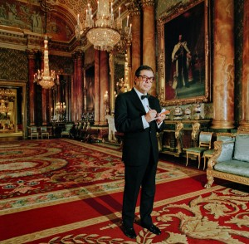
Photo by Jonathan Becker

Páez Medal of Art 2018
Gustavo Dudamel

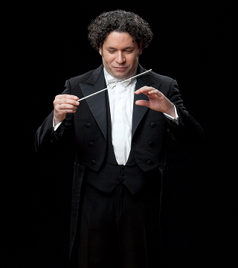
Photo by photographed by Mark Hanauer

The Páez will be bestowed during VAEA’s Annual Benefit Gala on December 18th, 2018 at the David Rubenstein Atrium in Lincoln Center, New York City.

The VAEA is honored to celebrate the work of Bob Colacello, an American writer, editor, photographer, curator and philanthropist, whose deep understanding of culture and fertile writing have contributed to the chronicling of America's contemporary history making him an ideal candidate for the The Páez 2017 Medal of Art.

Gustavo Dudamel’s outstanding contributions to the arts as a tireless advocate for music education, as well as his unique passion and talent for music have earned him a place in history as one of the greatest and most influential music conductors of all time. We are proud to recognize him with the The Páez 2018 Medal of Art.

The VAEA’s Annual Benefit Gala is a night to bestow the Páez Medal of Art and to celebrate the best of Venezuelan and US cultures. The evening will gather an international crowd to honor Bob Colacello & Gustavo Dudamel and to support VAEA’s bi-national mission in the arts.

This will be VAEA’s 7th Benefit Gala in New York City.

The 2018 Gala Leadership has the pleasure to invite you to VAEA’s Annual Benefit Gala:

Mr. & Mrs. Graydon Carter
Honorary Chairs

Mr. & Mrs. Gerrity Lansing
Gala Chairs

Mr. & Mrs. Reinaldo Herrera
Chairs
Advisory Board
The Venezuelan American Endowment for the Arts

Ali Cordero Casal
Chairman
The Venezuelan American Endowment for the Arts
& the Board of Directors

Damian Woetzel
Presenter Award Ceremony

Valeria Cordero
Director
The Venezuelan American Endowment for the Arts

The VAEA's Gala Committee

Adam Lippes & Alexander Farnsworth
Agnes Gund
Boris Izaguirre & Ruben Nogueira
Calvin Klein
Dani Bedoni
David Kamp & Aimee Bell
Dixon and Arriana Boardman
Ernesto Arambatzis & Frank Amadeo
Francesco & Alba Clemente
Gustavo Sever
Howard & Nancy Marks
HRH Prince Dimitri of Yugoslavia
Irene Grisanti
Jason Leonard & Juan José Reverol
John & Susan Hess
Jonathan Becker & Alexandra Kotur
Joseph & Annette Allen
Louise Grunwald
Lourdes Fanjul
Martin O'Connor & Jane Sarkin
Matt Ullian
Oliver Sarkozy & Mary Kate Olsen
Omar Hernandez
Paul Wilmot
Ricardo Brunstein
Ricardo Jaimes-Branger & Antonio Vasco
Seth Campbell
Sims Lansing
Stuart Parr & Ozlem Onal
Suydam (Sydie) Lansing
Valentin & Yaz Hernández
Vito Schnabel
Wendy Stark

With music by DJ David Rondón

Gala Information
Tuesday, December 18th, 2018, 7:00pm
David Rubenstein Atrium at Lincoln Center
61 West 62nd Street, New York, NY 10023 (Broadway between 62nd and 63rd streets)
Dress Code: Black Tie
Tickets and information: VAEArts.org – 917 2858232 (vaea)

About Bob Colacello
Bob Colacello is one of America’s most prominent and prolific biographical writers. As Special Correspondent for Vanity Fair, since 1984, he has profiled more than 100 cultural, social and political figures including King Juan Carlos of Spain, Prince Charles, Princess Gloria von Thurn und Taxis, William F. Buckley, Jr., Amalita Fortabat, Rudolf Nureyev, Liza Minelli, Eli Broad and Balthus.
From 1970 to 1983, Colacello was editor of Andy Warhol’s Interview magazine. His memoir of those years, Holy Terror: Andy Warhol Close Up, is considered the definitive biographical portrait of the Pop artist. His biography of the Reagans, Ronnie & Nancy: Their Path to the White House 1911-1981, has also been widely praised. He is currently writing a second book on the Reagans, covering their White House and later years.
Colacello is also the author of Studios by the Sea: Artists of the East End of Long Island (with Jonathan Becker) and of Bob Colacello’s OUT, a collection of his party pictures from the 1970s and 1980s. His photographs have been exhibited at P.S. 1, the Whitney Museum, the Warhol Museum, Mary Boone Gallery and Stephen Kasher Gallery, among other institutions.
He has given lectures on contemporary culture and politics at the Miami Art Museum, the De Young Museum of San Francisco, the Cleveland Museum of Art, the Aspen institute, Goldman Sachs, Christie’s, the Lyford Cay Club and the Ronald Reagan Presidential Library, among other venues. He has appeared in documentaries on Andy Warhol, Nancy Reagan, Robert Wilson, Yves Saint Laurent, Doris Duke, Diana Vreeland, Giovanni Agnelli and Studio 54, among other subjects.
In 2017, Colacello curated his first art exhibition, The Age of Ambiguity: Figurative Abstraction/Abstract Figuration, at the Vito Schnabel Gallery in St. Moritz, Switzerland. It included works by Jean Michel Basquiat, Jeff Koons, Sterling Ruby, Rashid Johnson, Jacqueline Humphries and Jeff Elrod, among others. He serves on the board of the Foundation of Art and Preservation in Embassies (FAPE), the President’s Council of the New York Academy of Art and the National Advisory Council of the AIDS Community Research Initiative of America (ACRIA).
Colacello received a BSFS degree from Georgetown University School of Foreign Service in 1969 and an MFA in film from Columbia University Graduate School of the Arts in 1971. He was born in Brooklyn, NY, in 1947, and lives in Long Island.

About Gustavo Dudamel
Driven by an unwavering belief in the power of music to heal, unite and inspire, Gustavo Dudamel is one of the most distinguished conductors of our day. From the great concert halls to classrooms, video screens and cinemas, Dudamel’s remarkable career of musical achievements and championing of access to the arts for young people around the world is a living example of music’s extraordinary capacity to transform lives.
Dudamel’s 2018/19 season will center around the centennial celebration of the Los Angeles Philharmonic and his tenth year as their Music & Artistic Director. Other highlights of the season include his debut at the Metropolitan Opera conducting Verdi’s Otello, tours with the Berlin Philharmonic, Munich Philharmonic, and Mahler Chamber Orchestra, and his first extended academic residency at Princeton University.
Under Dudamel’s direction, the LA Phil has become one of the leading orchestras in the world, admired for its unmatched commitment to new music, diversity and inclusion, and the development of ground-breaking digital initiatives. The celebration of the LA Phil’s 100th season showcases the extraordinary versatility and vision of both the orchestra and Dudamel himself, featuring more than 50 commissions from luminaries such as John Adams, Philip Glass, and Steve Reich, as well as leading young composers such as Julia Adolphe, Ashley Fure, Andrew Norman, Tyshawn Sorey, Kamasi Washington, and Du Yun. Dudamel will lead cross-genre collaborations with Herbie Hancock, MOBY, and Andrew Bird, Beethoven’s five piano concertos with Lang Lang as soloist, a performance at the Academy Awards, a tour of Asia, and more. The LA Phil will also plan to distribute 10,000 free tickets to underserved audiences around Los Angeles as a centennial gift to the community.
A lifelong advocate for music education and social development through art, Dudamel’s own childhood was shaped by his experience with El Sistema, the extraordinary program of immersive musical training initiated in 1975 by José Antonio Abreu. Entering his nineteenth year as Music Director of the Simón Bolívar Symphony Orchestra, Dudamel carries on the work of his late mentor with his ongoing commitment to El Sistema in Venezuela, and by supporting numerous Sistema-inspired projects around the world, including Big Noise in Scotland, Vienna’s Superar program, SerHacer in Boston, and El Sistema Sweden. His 2018 ‘Americas’ tour with the Vienna Philharmonic was highlighted by an Art and Citizenship workshop in Mexico City bringing together 300 young people from across North and South America in an expression of cultural solidarity. He has worked to raise awareness for the importance of music education by appearing at the United Nations and the White House, and delivered an address on the unity of the Arts and Sciences at the 2017 Nobel Prize Concert.
Gustavo Dudamel was born in 1981 in Barquisimeto, Venezuela. He began violin lessons as a child with José Luis Jiménez and Francisco Díaz at the Jacinto Lara Conservatory. He continued his violin studies with Rubén Cova and José Francisco del Castillo at the Latin American Academy of Violin. His conducting studies began in 1993 when he was hired as an Assistant Conductor with the Amadeus Chamber Orchestra. In 1996, he studied with Rodolfo Saglimbeni and was named Music Director of the Amadeus Chamber Orchestra. In 1999, he was appointed Music Director of the Simón Bolívar Youth Orchestra and began conducting studies with the orchestra’s founder, Dr. Abreu. Dudamel achieved international attention by winning the inaugural Bamberger Symphoniker Gustav Mahler Competition in 2004. He then went on to become Music Director of the Gothenburg Symphony (2007-2012), where he currently holds the title Honorary Conductor. Inspired by Dudamel’s early musical and mentoring experiences, the Gustavo Dudamel Foundation, a registered charity, was created in 2012 with the goal of promoting access to music as a human right and a catalyst for learning, integration, and social change.

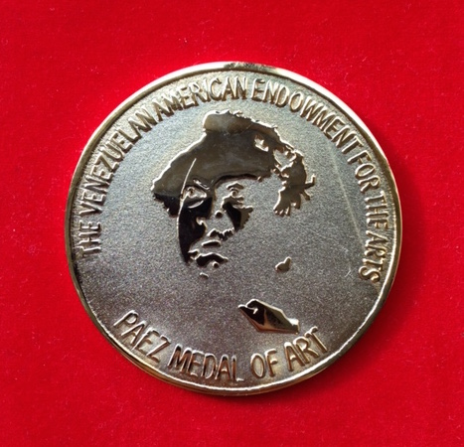
VAEA’s Páez Medal of Art

About The Páez Medal
The Páez Medal of Art is awarded once a year to an individual or group that has had an impact and contributed to the excellence, growth, support and proliferation of the arts in Venezuela and the United States; Previous recipients include: Marisol Escobar in 2016; Annie Leibovitz in 2015; Sofía Imber in 2014, Robert Wilson in 2013 and Carlos Cruz-Diez in 2012.

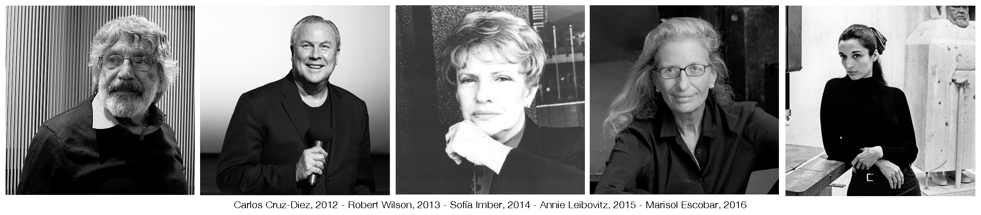
About VAEA
The VAEA is a NY based 501(c)3 public charity, founded on June 13, 1990 with the mission of promoting the best of Venezuelan and US cultures through bi-national cultural, educational and social programs.

For additional information visit VAEArts.org, call 917 2858232 (vaea) or email gala@vaearts.org

